**1.**

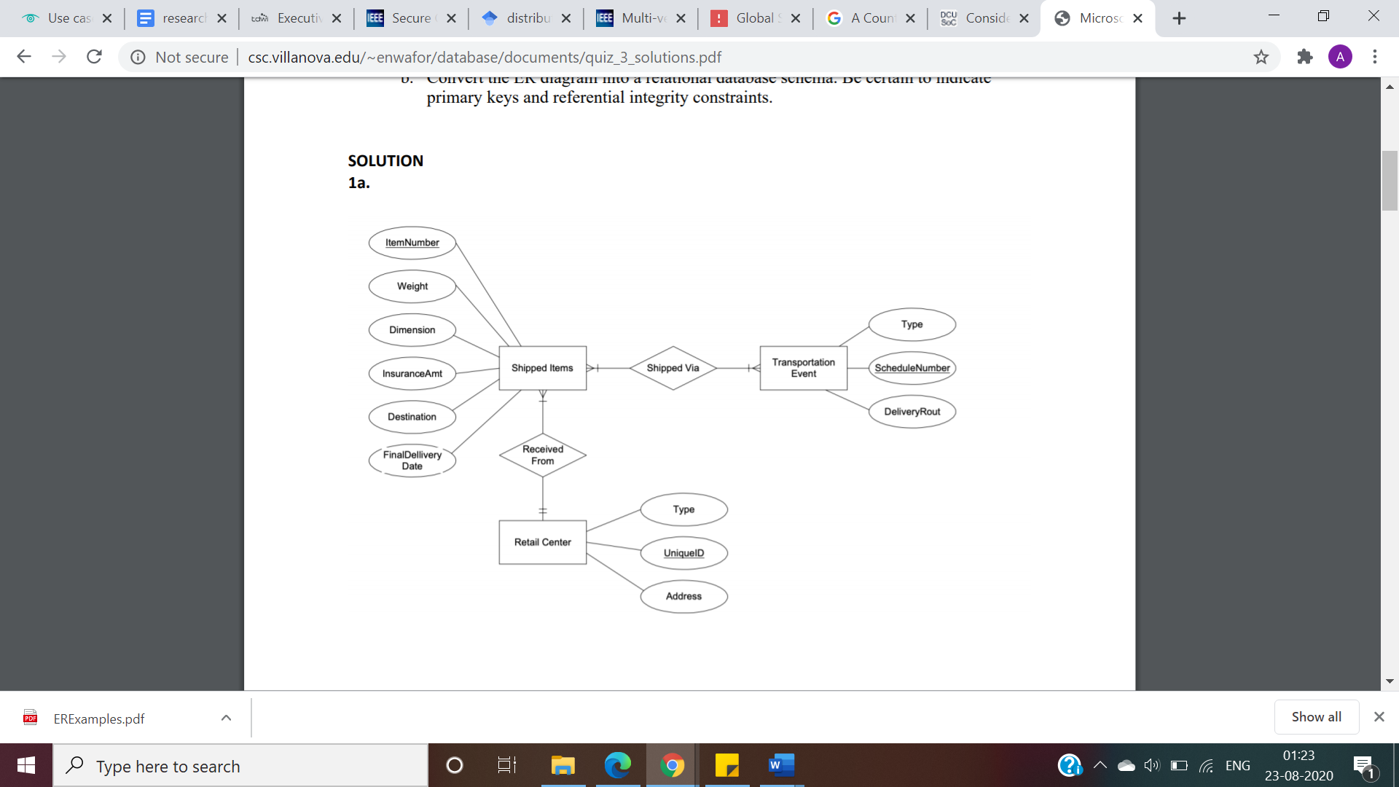

1. Composite attribute- address, weight (In kg, pounds etc.)
2. Can add a Derived attribute – No. of days (Final Delivery Date- shipment date) in Shipped Items table

**2.**

**Relationships**

A bus is allocated to a route and a route may have several buses.

• Bus-Route (m:1) is serviced by

A route comprises of one or more stages.

• Route-Stage (1:m) comprises

One or more drivers are allocated to each stage.

• Driver-Stage (m:1) is allocated

A stage passes through some or all of the towns on a route.

• Stage-Town (m:n) passes-through

A route passes through some or all of the towns

• Route-Town (m:n) passes-through

Some of the towns have a garage

• Garage-Town (1:1) is located in

A garage keeps buses and each bus has one `home' garage

• Garage-Bus (m:1) is garaged

